1965 College Bowl at Varsity Stadium - Toronto ON
 | R | Jack GURNEY
 | U | Ben MURRAY
 | HL | Ray MORGAN
 | JP | J R Tip LOGAN
 | DU | Bill MOULTON

1966 College Bowl at Varsity Stadium - Toronto ON
 | R | Jack GURNEY
 | U | Ben MURRAY
 | HL | J R Tip LOGAN
 | JP | Hugh WOOD
 | DU | Norm MAXWELL

1967 College Bowl at Varsity Stadium - Toronto ON
 | R | Norm MAXWELL
 | U | Ben MURRAY
 | HL | Bill MOULTON
 | FJ | Hugh WOOD
 | DU | J R Tip LOGAN

1968 College Bowl at Varsity Stadium - Toronto ON
 |  | R |  | Jack GURNEY
 | U |  | Hugh WOOD
 | HL |  | Jack SISSON
 | FJ |  | Bill MOULTON
 | DU |  | Norm MAXWELL

1969 College Bowl at Varsity Stadium - Toronto ON
 | R | Hugh WOOD
 | U | Ben MURRAY
 | HL | Ray MORGAN
 | FJ | Bob PARK
 | DU | Fred LUSCOMBE

1970 College Bowl at Varsity Stadium - Toronto ON
 | R | Norm MAXWELL
 | U | Hugh WOOD
 | HL | Bill MOULTON
 | FJ | Rob PARK
 | DU | J R Tip LOGAN

1971 College Bowl at Varsity Stadium - Toronto ON
 | R | Jack GURNEY
 | U | J R Tip LOGAN
 | HL | Bob PARK
 | FJ | Bill MOULTON
 | DU | Ray MORGAN
 | SB | Roger KELLEY

1972 College Bowl at Varsity Stadium - Toronto ON
 | R | J R Tip LOGAN
 | U | Hugh WOOD
 | HL | Bill MOULTON
 | FJ | Bob PARK
 | DU | Fred LUSCOMBE
 | SB | Roger KELLEY

1973 College Bowl at CNE Stadium - Toronto ON
R Fred LUSCOMBE
U J R Tip LOGAN
HL John DIFFIN
FJ | Ken GREEN
DU | Bill MOULTON
SB | Bob PARK

1974 College Bowl at CNE Stadium - Toronto ON
 | R | Bob PARK
 | U | Stan CROWLEY
 | HL | Bob BUTLER
 | FJ | Al PATTERSON
 | DU | Neil THOMPSON
 | SB | Bill MOULTON

1975 College Bowl at CNE Stadium - Toronto ON
 | R | Bill MOULTON
 | U | J R Tip LOGAN
 | HL | Murray TAYLOR
 | FJ | Gord SMITH
 | DU | Dave SHIELDS
 | SB | Stan CROWLEY

1976 College Bowl at Varsity Stadium - Toronto ON
 | R | Stan CROWLEY
 | U | Bob PARK
 | HL | Russ WILSON
 | FJ | Gord SMITH
 | DU | John SCHROEDER
 | SB | J R Tip LOGAN

1977 College Bowl at Varsity Stadium - Toronto ON
 | R | Ken GREEN
 | U | Peter MOORE
 | HL | Rob GORDON
 | FJ | Murray TAYLOR
 | DU | Keith BUCHANAN
 | SB | Neil THOMPSON

1978 College Bowl at Varsity Stadium - Toronto ON
 | R | J R Tip LOGAN
 | U | Neil THOMPSON

HL | Russ WILSON
FJ | Gord SMITH
BU | Roger KEELEY
SB | Al PATTERSON

1979 College Bowl at Varsity Stadium - Toronto ON
 | R | Stan CROWLEY
 | U | Bill MOULTON
 | HL | Bill RUDYK
 | FJ | John DIFFIN
 | BU | Bob BUTLER
 | SB | Brian COSTELLO

1980 College Bowl at Varsity Stadium - Toronto ON
 | R | Ken GREEN
 | U | Wayne FLEMING
 | HL | Murray TAYLOR
 | FJ | Ron WALSH
 | BU | Wayne LANG
 | BU | Phil LASSALINE

1981 College Bowl at Varsity Stadium - Toronto ON
 | R | Bob TURNBULL
 | U | Keith BUCHANAN
 | HL | Murray TAYLOR
 | FJ | Wayne STEELE
 | BU | Lloyd DES ROCHES
 | BU | Russ WILSON

1982 Vanier Cup at Varsity Stadium - Toronto ON
 | R | Stan CROWLEY
 | U | John GREENWOOD
 | HL | Bob GORDON
 | FJ | Marshall BAZYLEWICH
 | BU | Frank BRYSON
 | BU | David TAGIEFF

1983 Vanier Cup at Varsity Stadium - Toronto ON
R Bob BUTLER
U | Raymond MUIR
HL | Don HORSLIN
FJ | John KING
BU | Terry TREMBLAY
BU | Al WATERS

1984 Vanier Cup at Varsity Stadium - Toronto ON
 | R | Jack SCHROEDER
 | U | Donald WEBSTER
 | HL | Turk TRTANY
 | FJ | Randy WARICK
 | BU | Brian COSTELLO
 | BU | Patrick MULDOON

1985 Vanier Cup at Varsity Stadium - Toronto ON
 | R | Rick McFAYDEN
 | U | Ken GREEN
 | HL | Ross HUTCHINSON
 | FJ | Murray TAYLOR
 | BU | Gerry WHITE
 | BU | Bernie YOUNG

1986 Vanier Cup at Varsity Stadium - Toronto ON
 | R | Bill GLENDINNING
 | U | Peter MOORE
 | HL | Bob SCOTT
 | FJ | Don HORSLIN
 | BU | Wayne SHORTEN
 | BU | Neil THOMPSON

1987 Vanier Cup at Varsity Stadium - Toronto ON
 | R | Ken GREEN
 | U | Roy KEEFE
 | HL | Terry CONNELLY
 | FJ | Jamie KRAEMER
 | BU | Charlie REINER
 | BU | Bill RUDYK

1988 Vanier Cup at Varsity Stadium - Toronto ON
R | Bob SCOTT
U | Murray TAYLOR
HL | Jack ANDERSON
LJ | Gerry SLOBODIAN
BJ | Doug RIDEOUT
BU | John DIFFIN

1989 Vanier Cup at SkyDome - Toronto ON
 | R | Ken GREEN
 | U | Heinz BRADEMANN
 | HL | John CHISOLM
 | LJ | Bruce SCHWIEDER
 | BJ | Bill HARCOURT
 | BU | Ron PALUZZI

1990 Vanier Cup at SkyDome - Toronto ON
 | R | Brian DAVIS
 | U | Ray MUIR
 | HL | Peter EADIE
 | LJ | Hans VANDERDOE
 | BJ | Tom SMOLA
 | BU | Maurice LACHANCE

1991 Vanier Cup at SkyDome - Toronto ON
 | R | Doug RIDEOUT
 | U | Terry TREMBLAY
 | HL | Darryl BARON
 | LJ | John BRENTON
 | BJ | Bill LORFING
 | BU | Ray KEALEY

1992 Vanier Cup at SkyDome - Toronto ON
 | R | Murray TAYLOR
 | U | Dave BARR
 | HL | Andre PROULX
 | LJ | Bob DUMONCEAUX
 | BJ | Pat MULDOON
 | BU | John CHISOLM

1993 Vanier Cup at SkyDome - Toronto ON
R | Bob BUTLER
U | Ron MORIN
HL | John KEMP
LJ | Bob ARMSTRONG
BJ | Peter EADIE
BU | Scott GLOVER

1994 Vanier Cup at SkyDome - Toronto ON
 | R | Terry CONNELLY
 | U | Jack ANDERSON
 | HL | Miles FERGUSON
 | LJ | Al MAILLOT
 | BJ | Bruce GRAY
 | BU | Bob HAYES

1995 Vanier Cup at SkyDome - Toronto ON
 | R | Bernie YOUNG
 | U | Bob MADAMS
 | HL | John LAMONT
 | LJ | Grant COLLARD
 | BJ | John PETERS
 | BU | John CHISOLM

1996 Vanier Cup at SkyDome - Toronto ON
 | R | Ray MUIR
 | U | Bill LORFING
 | HL | John DILALLA
 | LJ | Paul CHAPMAN
 | BJ | Grant COLLARD
 | BU | Bob CORMIER

1997 Vanier Cup at SkyDome - Toronto ON
 | R | Harley McKAY
 | U | Cam DICKSON
 | HL | Larry BUTLER
 | LJ | Miles FERGUSON
 | BJ | Ray KEALEY
 | BU | Andrew ATKINS

1998 Vanier Cup at SkyDome - Toronto ON
R | Terry CONNELLY
U | John BRENTON
HL | Ken POIRIER
LJ | Jeff HARBIN
BJ | Al WALTERS
BU | Dino MARZINOTTO

1999 Vanier Cup at SkyDome - Toronto ON
 | R | Paul CHAPMAN
 | U | Brendan DOLAN
 | HL | Bruce HACKSHAW
 | LJ | James PATTERSON
 | BJ | Patrick MULDOON
 | BU | Gord SMITH

2000 Vanier Cup at SkyDome - Toronto ON
 | R | Jack ANDERSON
 | U | Bob HAYES
 | HL | Bob ARMSTRONG
 | LJ | Ron ARTELLE
 | BJ | Peter EADIE
 | BU | Bob SCAGGS

2001 Vanier Cup at SkyDome - Toronto ON
 | R | Al MITCHELL
 | U | John BRENTON
 | HL | George MONTANI
 | LJ | Jerry GUIDO
 | BJ | Alan KIRKPATRICK
 | BU | Andy ATKINS

2002 Vanier Cup at SkyDome - Toronto ON
R Bruce GRAY
U Ken POIRIER
HL Steve DOLYNIUK
LJ Grant MacKENZIE
BJ Brian SMALL
BU Brent YOUNG
2003 Vanier Cup at SkyDome - Toronto ON
 | R | Dino MARZINOTTO
 | U | Jerry GUIDO
 | HL | Al GATES
 | LJ | Michel PISONNEAULT
 | BJ | Greg MacLEAN
 | BU | Jay SCHROEDER

2004 Vanier Cup at Ivor Wynne Stadium - Hamilton ON
 | R | Peter EADIE
 | U | John LAMONT
 | HL | Dave WARD
 | LJ | Henry CHIU
 | BJ | Rick BEREZOWSKI
 | BU | John DILALLA

2005 Vanier Cup at Ivor Wynne Stadium - Hamilton ON
 | R | Dennis ABBOTT
 | U | Jim LINDSAY
 | HL | George MONTANI
 | LJ | Bruce HOCKSHAW
 | BJ | John PETERS
 | BU | Ron PALUZZI

2006 Vanier Cup at Griffiths Stadium - Saskatoon SK
 | R | Gord SMITH
 | U | Ken POIRIER
 | HL | Bob KLEIN
 | LJ | John DILALLA
 | BJ | Rene DIGNEAULT
 | SJ | Dean McNEILL
 | FJ | Herman MURPHY

2007 Vanier Cup at Rogers Centre - Toronto ON
R Ron PALUZZI
U Jamie PATTERSON
HL Glenn HILL
LJ Gord UNGER
BJ Brent YOUNG
SJ | Dave GATZA
FJ | John PETERS

2008 Vanier Cup at Ivor Wynne Stadium - Hamilton ON
 | R | Allan MAILLOT
 | U | John PARKER
 | HL | Walter BERRY
 | LJ | John DUFFIN
 | BJ | Glenn HILL
 | SJ | Rob CAISSIE
 | FJ | Frank WHITE

2009 Vanier Cup at Stade Telus UL - Quebec QC
 | R | John BRENTON
 | U | Jim LINDSAY
 | HL | John DILALLA
 | LJ | Patrick MacArthur
 | BJ | Lawrence OLIVIER
 | SJ | Dennis ZWARYCH
 | FJ | Henry CHIU

2010 Vanier Cup at Stade Telus UL - Quebec QC
 | R | Rene DAIGENAULT
 | U | Cam DICKSON
 | HL | Adelmo MONACO
 | LJ | Justin McINNES
 | BJ | Barry DEBAIE
 | SJ | John PRINGLE
 | FJ | Brent YOUNG

2011 Vanier Cup at BC Place Stadium - Vancouver BC
 | R | Murray DRINKWALTER
 | U | Grant McKENZIE
 | HL | George MONTANI
 | LJ | Tom CESARI
 | BJ | Alex MOTUZAS
 | SJ | Yves LEMELIN
 | FJ | Kevin McWILLIAM

2012 Vanier Cup at Rogers Centre - Toronto ON
R | Kelly EDGEWORTHY
U | Bernard DAIGNEAULT
HL | Robert MOQUIN
LJ | Adam HINKS
BJ | Ross SAUNDERS
SJ | Andrew BUBAR
FJ | Blair BROWN

2013 Vanier Cup at Stade Telus UL - Quebec QC
 | R | Greg MacLEAN
 | U | Colin SUTHERLAND
 | HL | Rob ISBISTER
 | LJ | Eric CLOUTIER
 | BJ | John DILALLA
 | SJ | Mike THORSON
 | FJ | Kevin LAMONT

2014 Vanier Cup at Stade Memorial Percival Molson - Montreal QC
 | R | Rene DAIGNEAULT
 | U | Marvin MULLANEY
 | HL | Vince WILLIAMS
 | LJ | Cody LAROCQUE
 | BJ | Brian GREIG
 | SJ | Ross FOXCROFT
 | FJ | Stephane ROY

2015 Vanier Cup at Stade Telus UL - Quebec QC
 | R | Henry CHIU (Ont)
 | U | James FOWLER (NB)
 | HL | Marc COBB (Ont)
 | LJ | Kevin RIOPEL (Que)
 | BJ | John DILALLA (Que)
 | SJ | Nigel BUSHE (BC)
 | FJ | Iain COOPER (Sask)
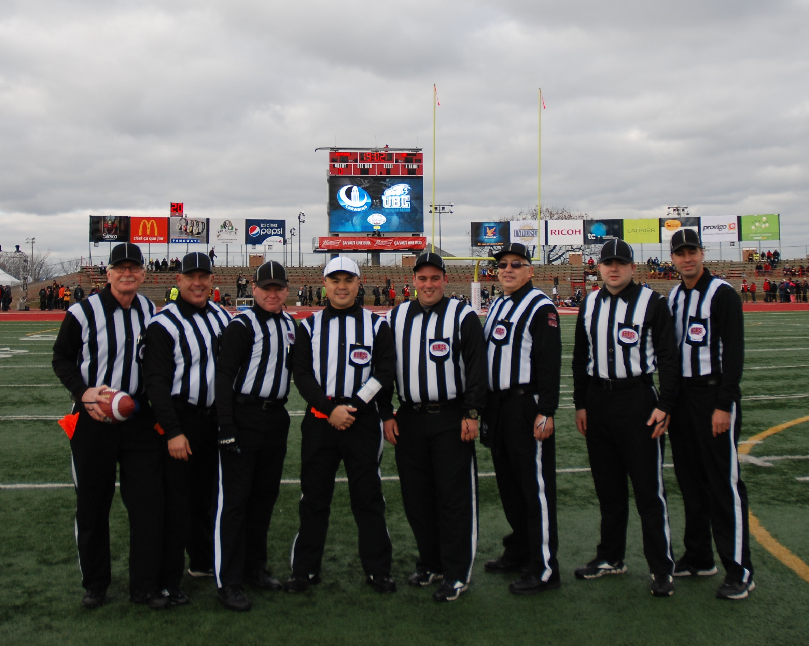

2016 Vanier Cup at Tim Hortons Field - Hamilton ON
R Kelly EDGEWORTHY
U Robert MOQUIN
HL Daniel ROY
LJ Keith MEDEIROS
BJ | John SKERRY
SJ | John PRINGLE
FJ | Kenneth McWILLIAM
SUB | Kevin MICKELBORO

2017 Vanier Cup at Tim Hortons Field - Hamilton ON
 | R | Greg MacLEAN
 | U | Kevin BAIRD
 | HL | Kyle MIKULIK
 | LJ | Charles LAMPRON
 | BJ | Francois BISSON
 | SJ | Ryan STARK
 | FJ | Kevin LAMONT
 | SUB | Henry CHIU

2018 Vanier Cup at Stade Telus UL - Quebec QC
 | R | Walter BERRY
 | U | Robert HENDRY
 | HL | Adam HINKS
 | LJ | Kent GAUTHIER
 | BJ | Kristian STRICKLAND
 | SJ | Barclay EASTON
 | FJ | Yvan GATIEN

2019 Vanier Cup at Stade Telus UL - Quebec QC
 | R | Kevin MICKELBORO
 | U | James FOWLER
 | HL | Marc BURRELLE
 | LJ | Daniel ROY
 | BJ | James CARLISLE
 | SJ | Laurent DUBREUIL
 | FJ | Adam DEMANIUK
2020 No game

2021 at Quebec City
R John P0PPLESTONE (Can West BCFOA)
U Mario THIVIERGE (RSEQ)
DJ Charles LAMPRON (RSEQ)
LJ Chris WALKER (OUA)
SJ Bruch CARTER (OUA)
BJ Wray DUNN (AUS)
FJ Ryan LANGE (CanWest)
Alt Brent YOUNG (RSEQ)

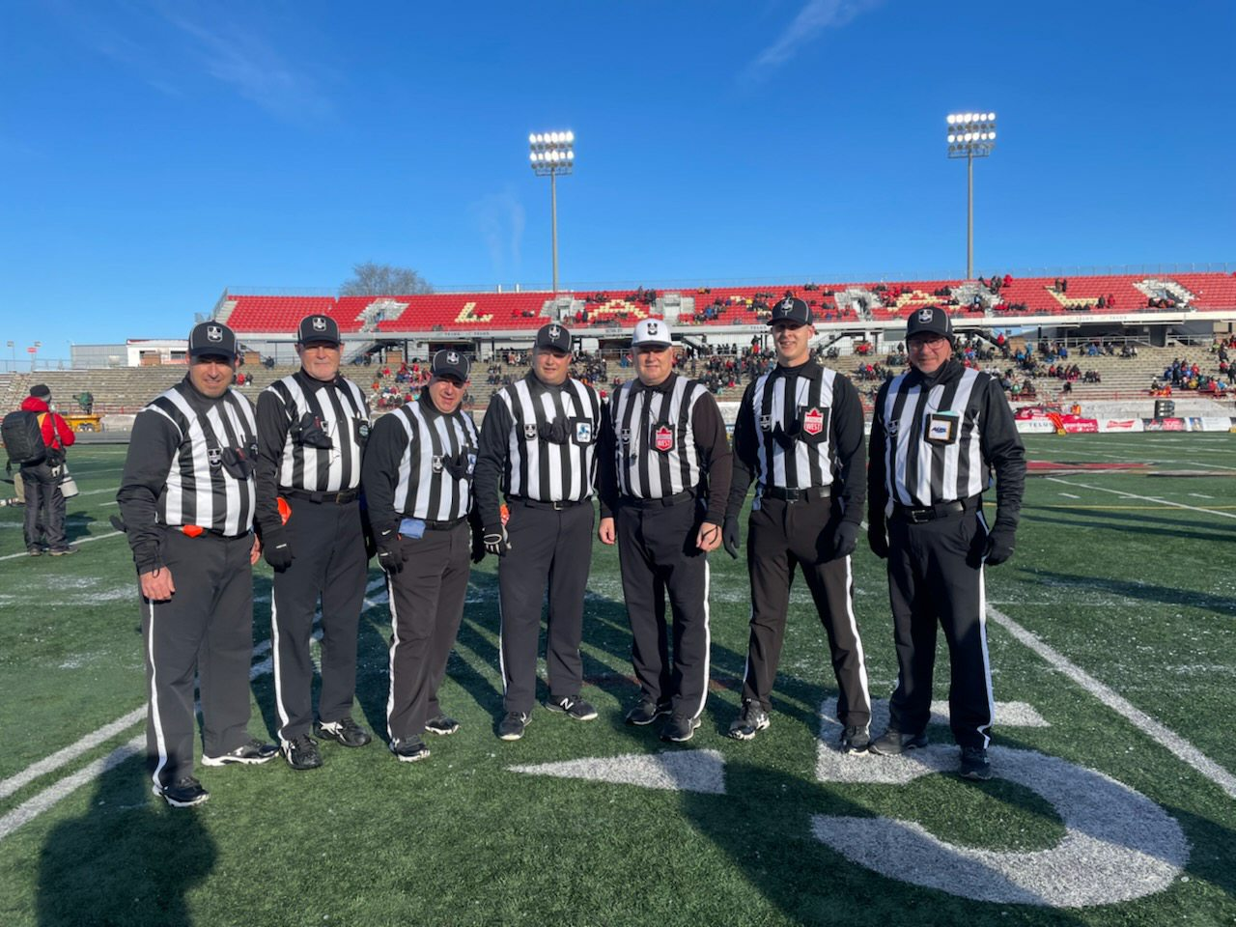

2022 at Quebec City
R Al GATES (AUS)
U Paul DUNCAN (Lakeshore)
DJ Tim LOUMAN-GARDINER (BC)
LJ Danny ROY (RSEQ)
SJ Ben CHAPDELAINE (Hamilton)
BJ Renald DULAC (RSEQ)
FJ Daniel FLEISCHHAKER (Regina)
Alt James BEELER (Nova Scotia)

2023 at Kingston Ont.
R Brent YOUNG (RSEQ, Que)
FJ Eric GASCON (RSEQ, Que)
DJ Vincent WILLIAMS (AUS, NS)
U Matt SPETTER (CanWest, Edmonton)
SJ Colin BAWN (AUS, NS)
LJ Eric GYEBI (OUA, Lakeshore)
BJ Darren COCHRANE (OUA)
Alt Daniel DOERKSEN (CanWest MB)

